ANNEX 3
LOT 2: Playground for the pre-school and primary school age group
Contractor is expected to deliver and install playgrounds for pre-school (aged 4-6 years old) and school children (7-13) ensuring their safety while providing space for enjoying free time by playing at an open space based on the technical specifications provided in the Tender Note.

- Playground
Raion: | Mukachevo Raion
City/Village: | Mukachevo
Address: | Andrii Lituna 15/3
Where is it located? | Mukachevo center of extracurricular education (students park)
Owner: | Communal
Description: | Children's playground from 6 to 12 years old with old benches.
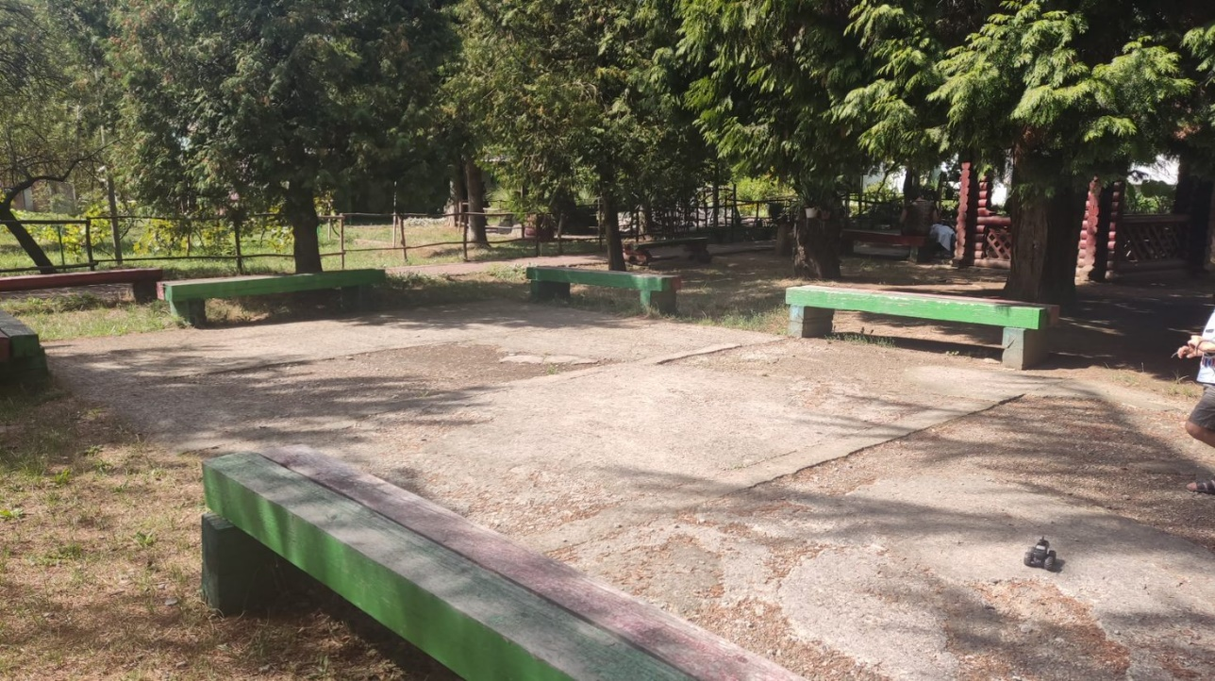

- Playground
Raion: | Uzhhorod raion
City/Village: | Tury Remeta
Address: | Turytsia village, street Tsentralna 134
Where is it located? | The area proposed for open space is the yard of an elementary school near the kindergarten, a bomb shelter is planned inside the building.
Owner: | It is communally owned by the village council.
Description of the site: | Site with ground cover and fence.
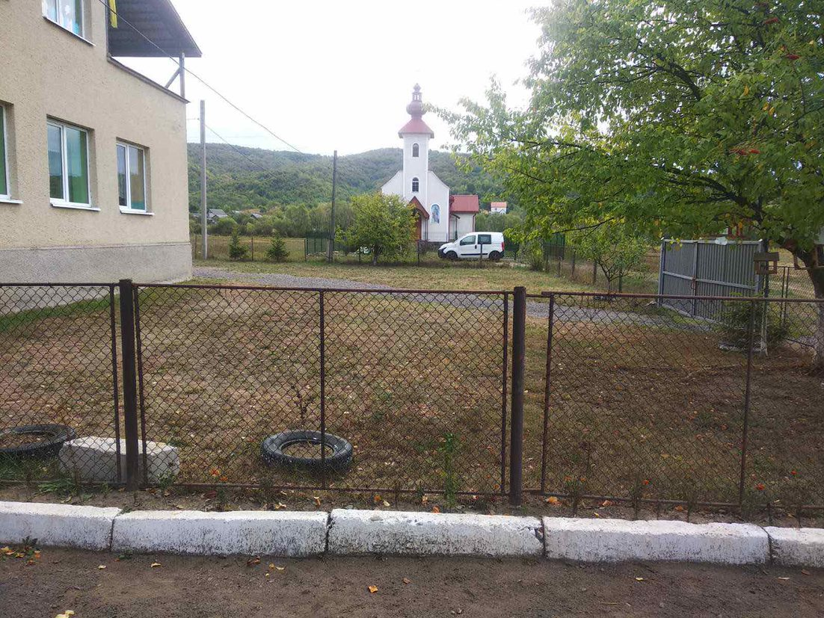

- Playground
Raion: | Uzhhorod raion
City/Village: | Perechyn
Address: | Perechyn, str. Uzhanska 9
Where is it located? | The area is located in the city center
Owner: | It is communally owned by the city council.
Site description: | A plot with a ground cover and a fence.
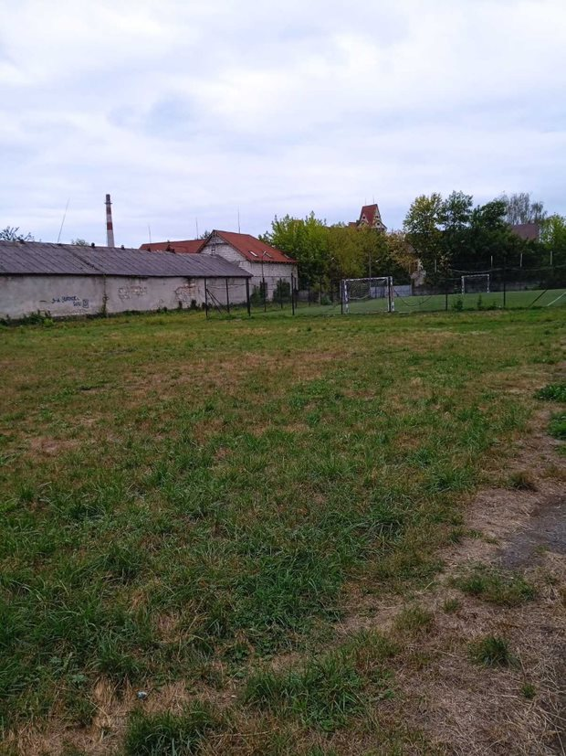

- Playground
Raion: | Khustskyi
City/Village: | Vyshkovo
Address: | 90454 smt. Vyshkovo, str. central square
Where is it located? | The site is located on the central square of the village opposite ZDO No. 1 "Veselka".
Owner: | Vyshkovo settlement council
Description of the site | Old children's playground available (swings, swings)

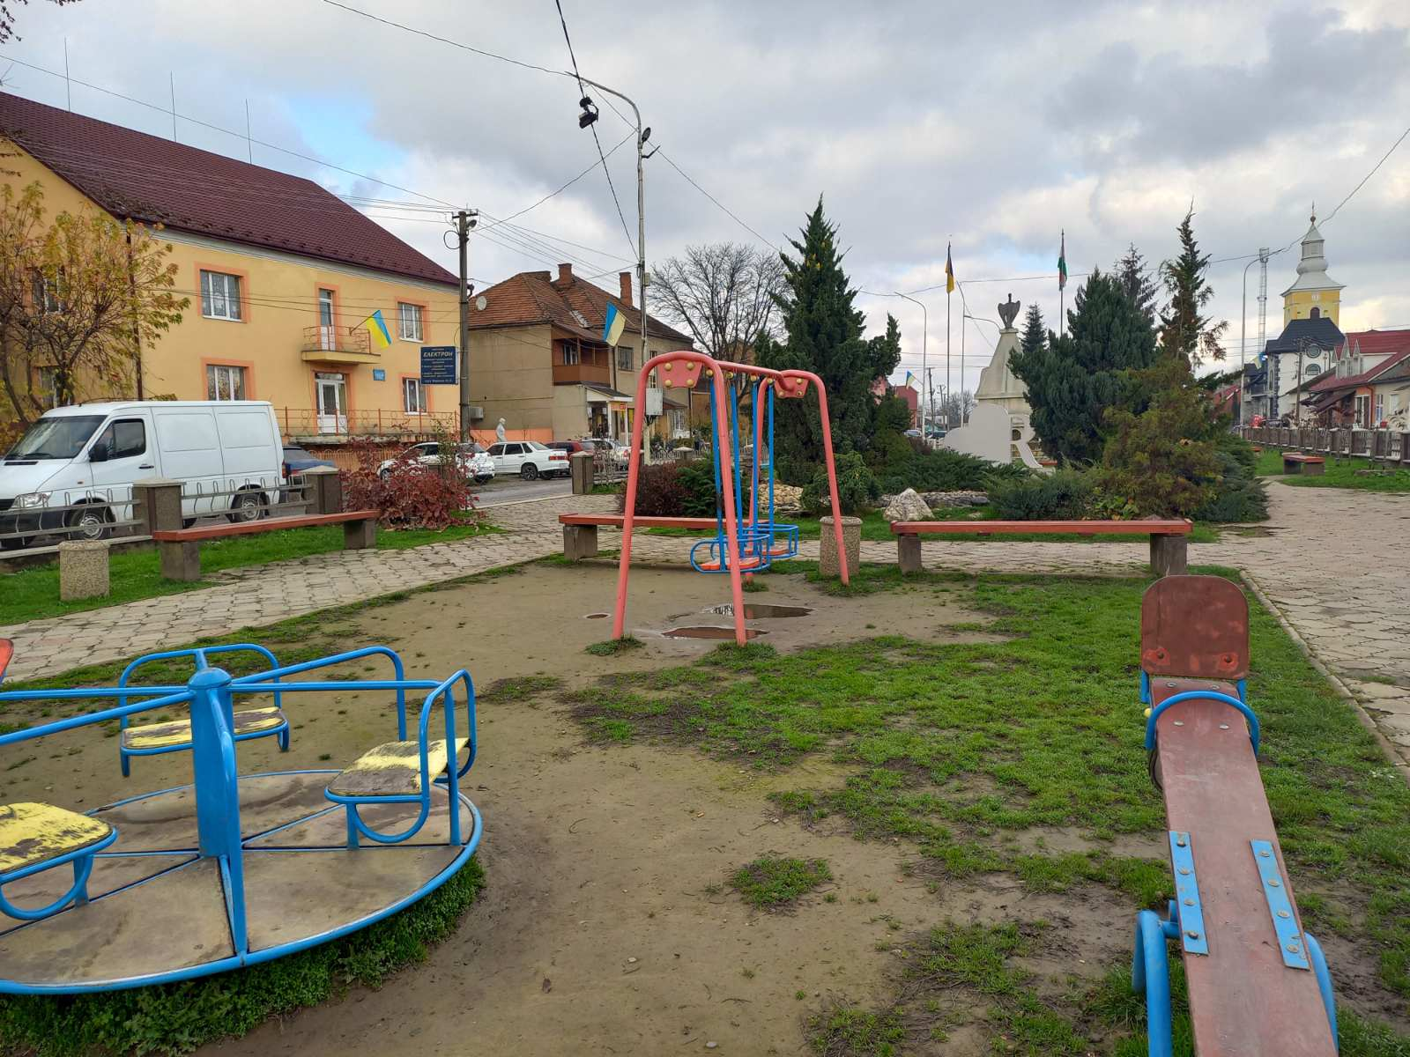

- Playground

Area | Berehivskyi
City/Village | Vylok
Address: | St. Shevchenko 38
Where is it located? | In the courtyard of the Vylotsky club
Owner: | Vylotsk Council
Description of the site | Yard 5x35, center of public recreation for children and young people, there is a football field nearby.

